Introduction

Preparation of plants and methods

# Rocket stats

## Motor

Motor: Cesaroni K1620 V-max

Total impulse: 2,439.6 Ns

Average thrust: 1619.5 N

Burn time: 1.5s

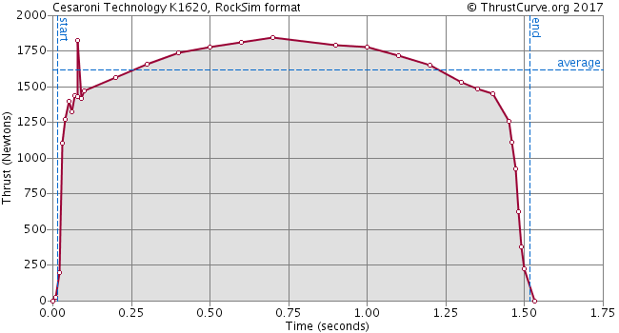

Rocket dimensions:

Length: idk

Mass with motors: about 11.8 kg (Pavel’s estimate)

Thrust to weight ratio: 14.0 (not sure this is right)

Recovery system: dual-deployment, redundant electronic charges. Drogue at apogee, main at 700 AGL. Both chutes deployed successfully.

Apogee: 4046 ft.

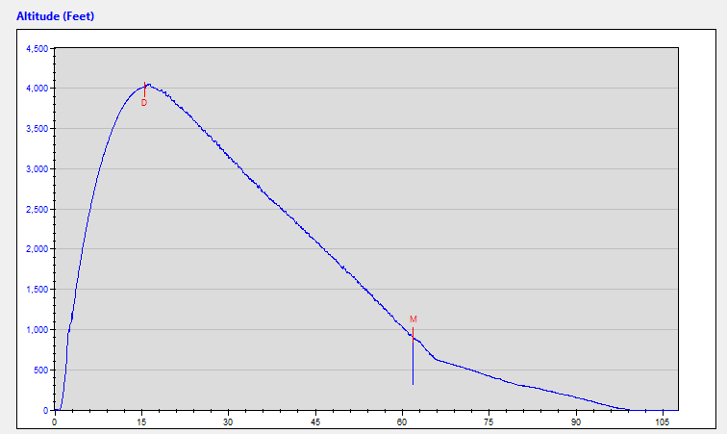

Curve 1

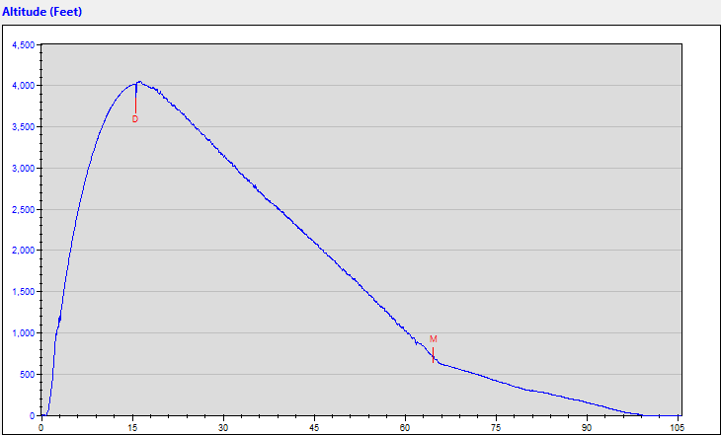

Curve 2

# Plant data

3 groups:

Flight

Launch Site Control

Lab Control